

**Omelette**

**Cheap, versatile and quick to make the humble omelette is a great dish to have in your repertoire. Eggs are an excellent source of good quality protein and are rich in vitamins A, C, E, K, B2, B6, B12; they are also a good source of minerals such as Zinc, Iron and Copper. Omelettes are a great dish for using up leftovers, why not try filling with ham, tomato, tuna, spinach, sweetcorn, roast chicken, smoked fish, mixed herbs or peppers; the list is endless.**

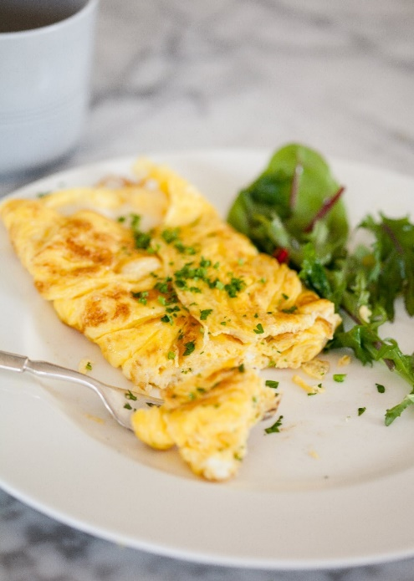**Serves 1**

* 2 Eggs
* 1 tsp Olive Oil

**Method**

1. Crack the eggs into a mixing bowl or jug and beat well with a fork
2. Heat 1 tsp of oil in a non-stick frying pan, pour in the eggs and tilt the pan to spread them evenly.
3. Using a non-metal spatula, ease around the edges as it starts to cook.
4. Gently push the setting egg into the centre of the pan from the edges to create ripples. This will allow the uncooked egg to be able to spread out easier and get direct contact with the heat. At this stage you can add any fillings that you would like to use. If using cheese make sure only to use a little.
5. Using a spatula, ease around the edges and shake the pan to loosen it from the bottom. Tip the pan to help fold the omelette over onto a plate.