

**Soda Bread**

**This quick and easy bread recipe will soon have you making your own freshly baked bread at home. Traditionally from Ireland this non yeasted bread uses baking powder to react with the acid from either buttermilk or yoghurt as a leavening agent. The use of whole meal flour and oats in the bread adds both to the flavor and to the nutritional benefit; increasing fibre levels and adding extra nutrients.**

 **Serves 6 (makes 1 loaf)**

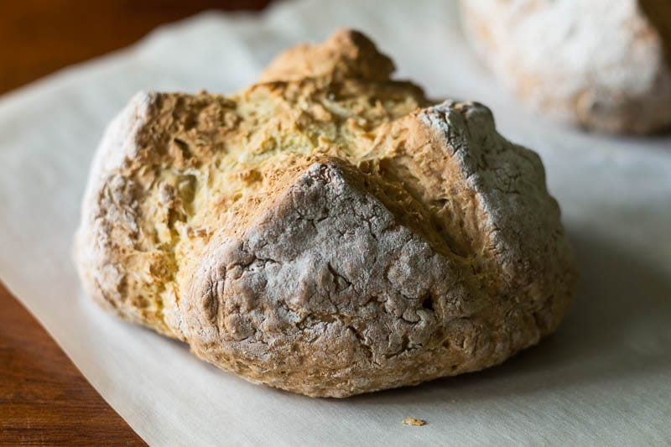**Ingredients**

* 150g self-raising Whole meal Flour
* 150g plain White Flour
* 50g Oats
* ½ tsp salt
* ½ tsp Bicarbonate of Soda
* 300ml Buttermilk

**Method**

1. Pre heat the oven to 220 ◦c
2. Tip the flours, oats, salt and bicarbonate of soda into a large mixing bowl and mix well.
3. Make a well in the centre and pour in the buttermilk, mixing quickly with a large fork to form a soft dough. (Depending upon the absorbency of the flour, you may need to add a little water if the dough seems too stiff but it should not be too wet or sticky.)
4. Turn onto a lightly floured surface and knead briefly. Form into a round and flatten the dough slightly before placing on a lightly floured baking sheet.
5. Cut a cross on the top, scatter with a few extra oats and bake for about 30- 45 minutes or until the loaf sounds hollow when tapped. Cool on a wire rack.