**Rye Bread topped with Avocado, Cherry tomatoes, Rocket and pickled Red Onion**

**This celebration on a plate is both nourishing for the eyes and the body. It’s packed with healthy fats from the avocado which are balanced well with the acidity of the red onion. Rye bread offers a rest from wheat and has a beautiful deep flavour. Rye contains high levels of fibre and is a good grain to aid in weight loss as it can help to make you feel fuller for longer.**

******Serves 2**

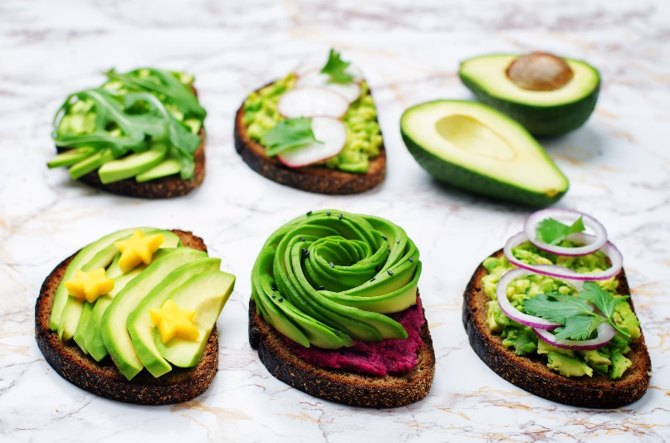**Ingredients**

* 1 x Avocado
* 2 x slices of Rye Bread
* 8 x Cherry Tomatoes
* 1 x small handful of Rocket
* ½ Red Onion
* 1 tbsp White wine vinegar
* 1 tbsp water
* Salt and Pepper

**Method**

1. Peel and finely slice the red onion, place in a bowl and add the vinegar and water. Leave to one side for 10 minutes, stirring occasionally.
2. Toast the rye bread and place onto your plate.
3. Cut the avocado in half and remove the stone. Using a table knife score the avocado flesh into a criss cross and run the knife around the inside of the skin to remove the flesh. Using a spoon remove the avocado onto the toast and gently crush. Season the avocado with a little salt and pepper.
4. Cut the cherry tomatoes in half and place on top of the avocado followed by a little rocket.
5. Finish the dish off with a scattering of the quick pickled red onion.