

**Cous cous salad with pan fried fish**

Cous cous is semolina which contains no fat, is a good source of fibre and releases energy slowly into our body. With plenty of vegetables and the addition of fish and dairy this recipe makes for a well-balanced meal. Play around with the recipe and change the vegetables and herbs depending on what you have in or what is in season.

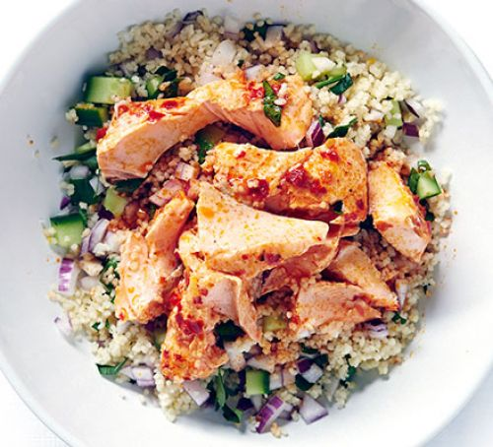**Serves 2** (Cost: £1.18 per serving)

**Ingredients**

* 50g Cous Cous
* 100ml Boiling water
* 1 Carrot grated
* 1 handful of chopped spinach
* 2 Spring onions
* 8 Cherry tomatoes
* ¼ Cucumber
* ½ zest of an Orange
* 1 handful of chopped mint
* 1 fillet of fish (salmon, tuna, hake, whiting, whole sardines or tinned fish)
* 50g feta cheese
* 6 Olives or pickled cornichons (de stoned and roughly chopped)

**For the dressing** (Cost: £.11 per serving)

* Juice of ½ an orange
* 2 tbsp olive oil
* 2 tbsp red wine vinegar
* Salt and pepper to taste

**Method**

1. Place the cous cous into a mixing bowl and add the zest of ½ an orange. Add 100mls of boiling water, give the cous cous a stir and then cover the bowl with a plate and leave it to steam for 5 minutes. Remove the plate and using a fork break up the cous cous and leave to one side
2. Wash all of the vegetables. Finely slice the spring onion and add to the cous cous. Finely dice the cucumber and add to the bowl. Cut the tomatoes into quarters and add to the bowl. Grate the carrot and roughly chop the spinach and mint and add to the bowl. Mix well and leave to one side.
3. Now it’s time to make the dressing. Place the oil, vinegar and orange juice in a cup and mix well. Add a small amount of salt and pepper.
4. To cook the fish, remove it from any packaging and place on kitchen paper to remove any moisture. Rub the fish with a little oil and then season with some salt and pepper. Put a frying pan on a medium heat and once the pan is hot place the fish into the pan skin side down. The fish will cook almost the whole way through skin side down and depending on the size of the fish will take about 5 minutes to cook.
5. To serve the dish portion out the cous cous on a plate, top with the dressing followed by the crumbled feta and finally top with the fish.

If you are interested you can take a look at the sustainable fish list online @ https://www.mcsuk.org/goodfishguide/search