

 **Minestrone soup with homemade pesto**

**This beautiful Italian soup is super easy and cheap to make. Any seasonal vegetables can be used. Whole meal pasta helps to make the soup more substantial and the homemade pesto is a delicious addition.**

**Serves 2**

****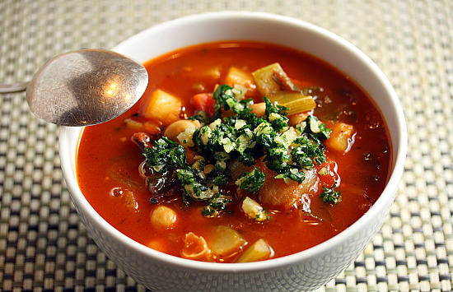(Cost: £.82 per serving)

**Ingredients**

* 100g Tinned white beans (cannellini, butterbeans or haricot)
* 1 Small red onion, finely diced
* ½ Celery stick, finely diced
* 1 Small potato, diced
* ½ Carrot, diced
* ¼ Courgette, diced
* 2 Cloves of garlic, roughly chopped
* 1 bay leaf
* 1 handful of spinach
* 75g Whole meal pasta
* 1 x 400g tin of chopped tomatoes
* 1 Small bunch of basil
* 2 Tbsp red wine vinegar
* 500ml water
* Salt and pepper to taste

**For the pesto** (Cost: £.30 per serving)

* 1 Large bunch of basil
* ½ Garlic clove
* 2 Tbsp of pine nuts
* 2 Tbsp parmesan cheese
* Olive oil
* Salt and pepper to taste

**Method**

1. Start to chop all of the vegetables except the spinach. Keep them an even size so that they all cook the same, chop the carrot and potato smaller as they take longer to cook.
2. Heat the olive oil in a saucepan and add the bay leave and the chopped vegetables apart from the tomato and spinach. Sweat very slowly on a medium/low heat for around 5 minutes until soft, but not brown.
3. Now add the fresh tomato along with the red wine vinegar. Turn the heat up slightly and reduce the vinegar. Now add the tinned tomatoes, water and the tinned beans. Bring the soup to the boil and then reduce to a simmer.
4. Place the pasta in a clean tea towel and using a rolling pin roughly break it up and add to the soup. Leave the soup to cook for 10 – 15 minutes on a gentle simmer while you make the pesto.
5. Place a frying pan on a medium heat and add the pine nuts. Dry fry them until they are lightly golden.
6. Add the garlic and basil to a pestle and mortar along with a splash of olive oil and grind into a smooth paste. Add the pine nuts and crush into the basil mix, adding more olive oil if needed. Finish by adding the parmesan and salt and pepper to taste.
7. Make sure that the soup is cooked by checking a piece of potato. Once cooked serve in bowls with a good spoon full of pesto on top.

**If you have left over pesto, pop it in the fridge, it will last for 3 days and is great for a quick pasta dish.**